

Company Overview

ChatGPT is an AI-powered chatbot developed by OpenAI, built on the GPT (Generative Pre-trained Transformer) architecture. OpenAI, founded in 2015, specializes in artificial intelligence research with the mission to ensure that AI benefits all of humanity. ChatGPT utilizes natural language processing (NLP) to generate human-like responses in conversations. It is widely used for customer support, content creation, education, and more.

# Product Dissection and Real-World Problems Solved by ChatGPT:

ChatGPT is an advanced AI language model developed by OpenAI, designed to process natural language inputs and generate human-like responses. The product consists of several key components, including input processing, model computation using transformer-based deep learning, output generation, and continuous learning through user feedback.

It leverages vast datasets and reinforcement learning techniques to enhance accuracy and relevance. ChatGPT has solved various real-world challenges across industries. In customer support, it automates responses, reducing operational costs and improving response times. In education, it acts as a virtual tutor, assisting students with explanations and test preparation.

Content creators use ChatGPT for blog writing, marketing copy, and creative storytelling, while developers rely on it for coding assistance and debugging. Additionally, it streamlines healthcare by offering symptom analysis and summarizing medical literature. Legal professionals utilize it for contract drafting and case law research, and businesses enhance productivity through AI-driven task management. By addressing these challenges, ChatGPT has become a transformative tool, driving efficiency and innovation across multiple domains.

|  |  |
| --- | --- |
|  |  |

Real-World Challenges and Solutions

Challenge 1: Handling Misinformation and Bias

Problem: ChatGPT generates responses based on its training data, which may contain biases or misinformation. This can lead to misleading or incorrect answers.

Solution

- OpenAI has implemented reinforcement learning from human feedback (RLHF) to improve response quality.

- Continuous updates and fine-tuning of the model help in mitigating biases.

- AI ethics teams actively review and refine datasets to reduce misinformation.

Challenge 2: Managing High Computational Costs

Problem: Running AI models like ChatGPT requires significant computational power, leading to high operational costs and potential latency issues.

Solution

- OpenAI uses optimized model compression techniques to reduce computational overhead.

- Deploying hybrid cloud and edge computing solutions helps balance load and efficiency.

- OpenAI offers different model sizes (e.g., GPT-3.5, GPT-4) to allow users to choose based on their needs.

Challenge 3: Ensuring Data Privacy and Security

Problem: User interactions with ChatGPT could contain sensitive information, raising concerns about data privacy and security.

Solution

- OpenAI does not store personally identifiable information from conversations.

- Data encryption and strict access control measures are implemented to secure user data.

- Organizations using ChatGPT for business applications can integrate it with private cloud or on-premises solutions for enhanced security.

## Challenge 4: Understanding Context and Long Conversations

Problem: ChatGPT sometimes struggles with maintaining long conversation contexts and may forget previous interactions.

Solution

- OpenAI has improved the context window in newer models to remember more information within a conversation.

- Implementing memory retention techniques helps track user preferences over multiple interactions.

- External databases and APIs can be integrated to enhance ChatGPT’s contextual understanding.

Top Features of ChatGPT

## 

1. Natural Language Understanding (NLU):

ChatGPT comprehends and processes human language with high accuracy, enabling smooth and context-aware conversations.

1. Context Retention:

It remembers context within a conversation, allowing for coherent multi-turn discussions and follow-up queries.

1. Multi-Industry Applications:

ChatGPT is versatile, assisting in customer support, education, healthcare, legal research, and software development.

1. Content Generation:

It helps create blog posts, marketing copy, product descriptions, stories, and social media posts efficiently.

1. Code Assistance:

ChatGPT generates, explains, and debugs code, making it valuable for developers and programmers.

1. Multilingual Support:

It understands and responds in multiple languages, facilitating global communication and accessibility.

1. Sentiment Analysis and Personalization:

It can analyze tone, sentiment, and user intent, allowing for more personalized and relevant responses.

1. Task Automation:

Businesses use ChatGPT for automating repetitive tasks like email drafting, scheduling, and data analysis.

1. API Integration:

Companies integrate ChatGPT into applications, chatbots, and workflows through APIs, enhancing automation and productivity.

1. Scalability and Adaptability:

Different versions (GPT-3.5, GPT-4) allow users to choose models based on performance needs and cost-effectiveness. These features make ChatGPT a powerful tool across various domains, improving efficiency, engagement, and innovation.

# Schema Description

A relational database schema for ChatGPT’s conversation handling system consists of multiple tables to store user interactions, conversation history, API logs, and responses. The schema ensures efficient data retrieval and management for seamless chatbot operations.

1. Users Table

Stores user-related information

* User_Id (PK) : Unique identifier for each user
* Name : Name of the user (optional)
* Email : User email (if registered)
* Created_At : Account creation date

1. Conversations Table

Tracks conversations initiated by users.

* conv_id (PK) : Unique identifier for each conversation
* user_id (FK) : Links conversation to a user
* start_time : Timestamp when the conversation started
* end_time : Timestamp when the conversation ended

1. Messages Table

Stores individual messages exchanged within conversations.

* msg_id (PK) : Unique identifier for each message
* conv_id (FK) : Links message to a conversation
* sender : Indicates whether the message is from the user or AI
* text :Message content
* timestamp : Time when the message was sent

1. API Logs Table

Tracks API requests and responses for analytics and debugging.

* log_id (PK) : Unique identifier for each log
* user_id (FK) : Links API request to a user
* request_text : User query submitted to ChatGPT
* response_text : AI-generated response
* request_time : Timestamp when request was made

# Relationships Between Tables

1. Users → Conversations (One-to-Many) – A user can have multiple conversations.

2. Conversations → Messages (One-to-Many) – A conversation consists of multiple messages.

3.Users → API Logs (One-to-Many) – Each API request is logged per user. This schema ensures efficient data management for handling user interactions, tracking conversations, and optimizing ChatGPT’s performance.

# ER -Diagram:

Let's construct an ER diagram that vividly portrays the relationships and attributes of the entities within the ChatGPT schema. This ER diagram will serve as a visual representation, shedding light on the pivotal components of ChatGPT data model. By employing this diagram, you'll gain a clearer grasp of the intricate interactions and connections that define the platform's dynamics.

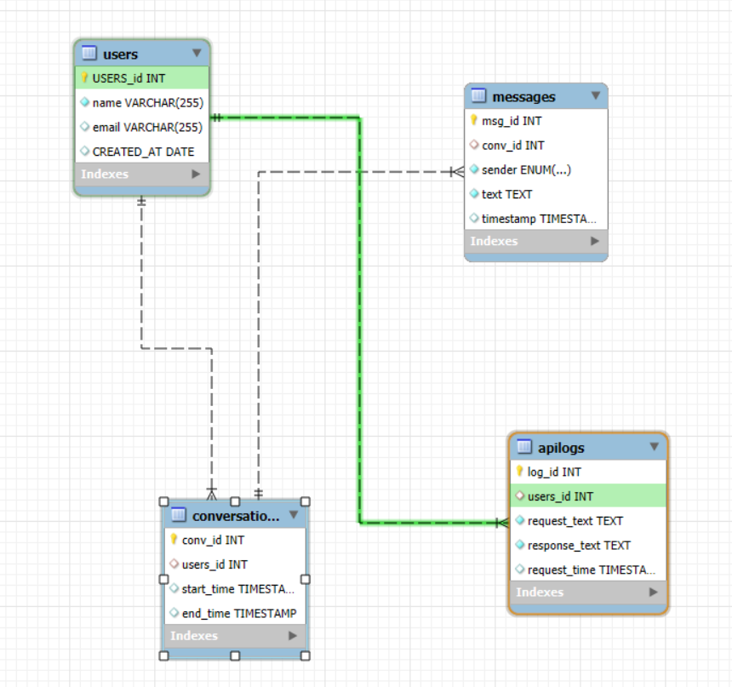

# Conclusion

ChatGPT has revolutionized AI-driven conversations with its advanced NLP capabilities. Despite challenges such as misinformation, computational costs, and privacy concerns, OpenAI has implemented robust solutions to improve the model’s reliability. Its rich feature set, flexible schema design, and scalable architecture make it an essential tool for various industries, including customer support, content creation, and programming assistance. Moving forward, advancements in AI ethics and memory retention will further enhance ChatGPT’s effectiveness in real-world applications.

|  |  |
| --- | --- |
|  |  |